**Automated cocoa garden robot and real-time cocoa disease analysis using CNN**

Supphakon Yimi1 Jirapong Thawonkaew 1 Thapanawat Chooklin1 and Kutsalin Thipmanosing1

*1Princess Chulabhorn Science High School Nakhon Si Thammarat, 120 Village No.1, Sunanan Road, Bangchak Subistrict, Mueang Nakhon Si Thammarat District, Nakhon Si Thammarat 80000, Thailand*

*\*E-mail: t.lookmee@pccnst.ac.th*

**Abstrct**

At the present, agriculture is an important part of human life because it is the main food producer for the people. Cocoa, as a future Thai economic plant, will play an important role in strengthening the future economy of Thailand. However, due to climate change, both the rainy season with a large amount of rainfall and the hot season that has to face a more severe drought than usual. The more abundant rainfall has created a large number of swamps in the farm, leading to the spread of cocoa diseases such as black pod disease, swollen shoot virus. As a result, farmers encounter obstacles in farming due to the spread of cocoa diseases. If not prevented or carefully cared for, it may spread to other plants, resulting in damage to agricultural products, poor quality products, and leading to massive loss of income for farmers. Thus, the creators have developed an automatic cocoa garden care robot and checked for plant diseases using Convolutional Neural Network by using a camera to capture images of cocoa trees and then send them to the processing unit to analyse abnormalities of the cocoa tree so that farmers can be informed and prevent the spread effectively. The robot can move automatically along the path specified by the farmer, covering the plants in the farm. The developed robot will help farmers take care of their plants efficiently, resulting in quality agricultural products, saving both time and labour. Including creating sustainable income for farmers**.**

**Keywords:** Climate Change, Cocoa Disease, Convolutional Neural Network**,** AutomaticRobot

**INTRODUCTION**

At present, agriculture is an important part of human life because it is the main food producer for the people. Cocoa, the Thai future cash crops, will play an important role in strengthening the future economy of Thailand. In 2023, 80% of cocoa production will be sold domestically and 20% will be exported to neighbouring countries, which is expected to generate sustainable income in the future. However, due to the problem of abnormal weather changes or Climate Change that affects the environment in various ways, causing both the rainy season to have a large amount of rainfall, including the hot season that causes more severe drought than usual. The more abundant rainfall than usual has created a large number of swamps in the plantation, leading to the spread of cocoa plant diseases such as black pod disease and swollen shoot virus, causing farmers to encounter the obstacles. If not prevented or taken care of carefully, it may spread to other plants, resulting in damage to agricultural products, poor quality products, leading to a large loss of income for farmers. Therefore, the developer has developed an automatic cocoa plantation care robot and analysed plant diseases in cocoa to let farmers know and prevent the spread effectively.

**EXPERIMENT PROCESS**

The main control centre of the robot is the Raspberry Pi 4, which receives data from various sensors: the GPS sensor, the MPU sensor, and the Webcam camera for analysis and processing. The secondary control centre is the NodeMCU ESP32, which controls the motors via the Motor Driver. It communicates with the main control centre to maintain the robot's path from the analysed sensor data. The battery provides power to the control centre and motors.

**Figure 1** Diagram of robot’s system

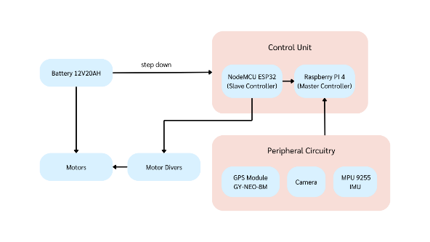

**Figure 2** Model of robot

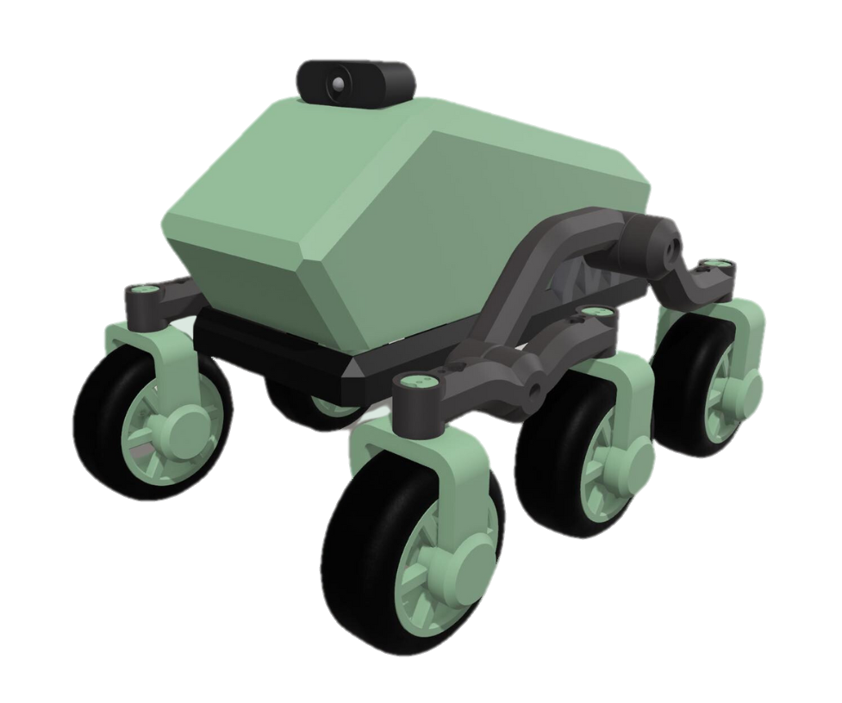

To control and guide the robot, we will take the filtered data from GPS and MPU to tell the position of the robot and let the control centre analyse and command the robot to move along the specified path

**Figure 3** Diagram of autonomous movement system.

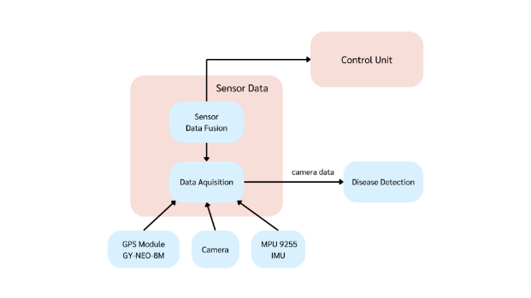

The authors used YOLOV8, which is based on Convolutional Neural Networks (CNN). The datasets used for training were PlantDoc, a dataset of 2,569 images of 13 plant species and 30 classes (disease and health), and Cocoa Disease Dataset, a dataset of 3,009 images of cocoa with 4 classes: Blackpod, Frostypod, Mirid, and Healthy.

**RESULTS**

Farmers set coordinates of various points for the robot to move to check various data through the use of an application via a web server.

**Figure 4** Web server

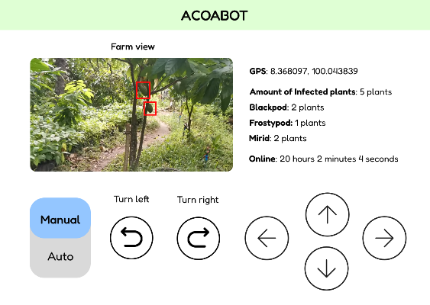

From the training results of YoloV8 model with Cocoa Disease Dataset which has 4 classes: Blackpod, Frostypod, Mirid and Healthy, the results are as follows.

**Figure 5** F1-curve

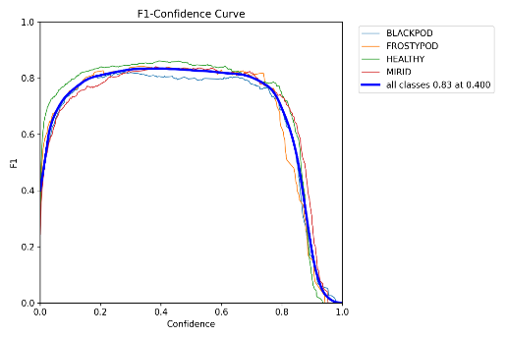

**Figure 6** *Confusion matrix*

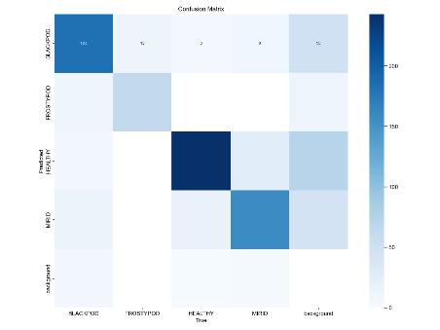

**Figure 7** AI Cocoa Disease Prediction

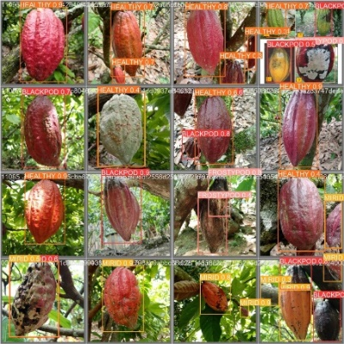

Deploying AI on Raspberry Pi 4, when the camera finds cocoa fruits that are likely to be diseased, it will notify farmers, which can be specified as the robot's latitude and longitude coordinates to know the location of the diseased cocoa trees in the garden as follows:

**Figure 8** AI Prediction on Raspberry Pi

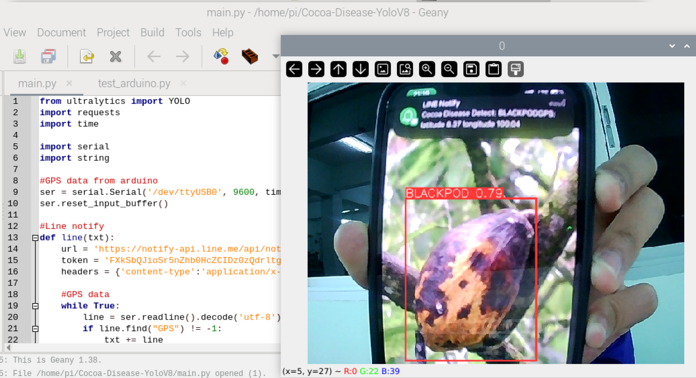

**CONCLUSION**

In developing the automatic cocoa plantation care robot and checking plant diseases in cocoa in real time with CNN, the main objective is to help farmers reduce damage to cocoa production from plant disease problems. In addition, it also focuses on collecting important data for analysis and more systematic management of cocoa plantations. From the development, it was found that farmers can be aware of the status of plant diseases and take preventive or treatment actions quickly and efficiently. Working in real time, the robot can detect and report the status of plant diseases and the environment in the cocoa plantation. The data can be sent through the server, allowing farmers to know the information and various statuses of the robot in the cocoa plantation, which helps farmers adjust the management of the cocoa plantation to suit the environment and needs.

**ACKNOWLEDGMENTS**

This project was able to be successfully completed due to the kindness and support from Mr. Thapanawat Chooklinand, Ms. Kutsalin Thipmanosing,and particularly Princess Chulabhorn Science High School Nakhon Si Thammarat who kindly gave advices and suggestions on contributing equipments and improving various defects of the report book until this research was successfully completed.

**REFERENCE**

Davinder Singh, Naman Jain, Pranjali Jain, Pratik

Kayal, Sudhakar Kumawat, and Nipun Batra. 2020. PlantDoc: A Dataset for Visual Plant Disease Detection. In Proceedings of the 7th ACM IKDD CoDS and 25th COMAD (CoDS COMAD 2020). Association for Computing Machinery, New York, NY, USA, 249–253. https://doi.org/10.1145/3371158.3371196 [accessed 6 Jan, 2024]

Miss Nyarko, COCOA DISEASE DETECTION Dataset

.Roboflow , 2023. [Online]. Available: https://universe.roboflow.com/miss-nyarko-s2gtm/cocoa-disease-detection [accessed 6 Jan, 2024]

Deep Neural Networks and Kernel Density

Estimation for Detecting Human Activity Patterns from Geo-Tagged Images: A Case Study of Birdwatching on Flickr - Scientific Figure on ResearchGate. Available from: https://www.researchgate.net/figure/YOLO-network-architecture-adapted-from44_fig1_330484322 [accessed 6 Jan, 2024]

W. Lv et al., DETRs Beat YOLOs on Real-time O bject Detection. 2023.

Jocher, G., Chaurasia, A., & Qiu, J. (2023).

Ultralytics YOLO (Version 8.0.0) [Computer software]. <https://github.com/ultralytics/ultralytics> [accessed 2 Jan, 2024]